5.5 Empirical formula
Name: ____________________ Class: ____________________ Due date: 10.12
1. What is the empirical formula of an oxide of iron, formed by reacting 2.24 g of iron with 0.96 g of oxygen? （ ）
A FeO B Fe₂O C Fe₂O₃ D Fe₃O₄

2. Analysis of a compound formed between magnesium and nitrogen showed it contained 14.4 g of magnesium and 5.6 g of nitrogen.
What is the empirical formula of the compound? （ ）
A Mg₂N₃ B Mg₃N₂ C Mg₄N₆ D Mg₆N₄

3. An oxide of sulfur is 40% sulfur and 60% oxygen.
What is its empirical formula? （ ）
A. SO₂ B. SO₃ C. S2O₆ D. S2O₃

4. Aluminium oxide has the formula Al₂O₃.
Which statement about aluminium oxide is correct? （ ）
A 2 g of aluminium atoms are combined with 3 g of oxygen atoms.
B 2 g of aluminium atoms are combined with 3 g of oxygen molecules.
C Aluminium oxide has a relative molecular mass of 102.
D Pure aluminium oxide contains a higher mass of oxygen than of aluminium.

5. - (0620-S 2016-Paper 2 (Extended)/1-Q8) - USING MOLES
A compound,X,contains $40.0\%$ carbon, $6.7\%$ hydrogen and $53.3\%$ oxygen by mass.
The relative molecular mass, $M_{r}$ of $X$ is 60.
What is the molecular formula of X? （ ）
A CHO B $CH_{4}O$ C C₂H₄O D. C₂H₄O₂

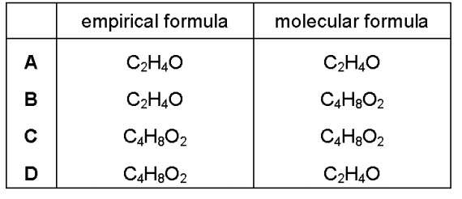
6. The relative molecular mass of an alcohol is 88.
Its percentage composition by mass is: C, 54.5%; H, 9.1%; O, 36.4%.
Which row shows the empirical formula and molecular formula for this alcohol? （ ）

7. Iodine forms an oxide which has the composition by mass: I, 76.0%; O, 24.0%.
(i) Use this information to determine the empirical formula of this oxide of iodine.

empirical formula
(ii) Another oxide of phosphorus has the empirical formula P₂O₃.
One molecule of this oxide of phosphorus contains four atoms of phosphorus.
Calculate the mass of one mole of this oxide of phosphorus.

mass =
8. Many organic compounds, such as alcohols, carboxylic acids and esters, contain the elements carbon, hydrogen and oxygen only.
(a) Compound R has the following composition by mass: C, 60.00%; H, 13.33%; O, 26.67%.
Calculate the empirical formula of compound R.

empirical formula =
(b) Compound S has the empirical formula C₂H₄O and Mr of 88.
Calculate the molecular formula of compound S.

molecular formula =

